Computer Science - Data Structures

# Overview

How is data stored in computer memory, and what algorithms can be used to make data access and manipulation quicker.

# Array

# Tree

A tree is a non-linear (more than on piece of data can follow another) data structure that forms a hierarchal arrangement of data. The top node of a data tree is called a root and the bottom nodes are called leaves if they have no children. A subtree consists of a node and all its decendants.

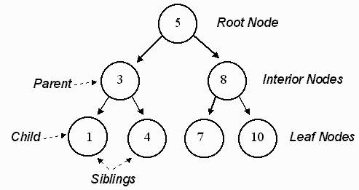

There are many different types of data tree:

Binary Search Tree

Binary trees have at most two node children, a search tree has the node assigned by the following rules:

* all values unique
* left subtree contains values less than self
* right subtree contains values more than self

Common operations on the tree are:

* insert - add new node
* search - find node
* delete - delete node
* is_valid? - check if given search tree is valid
* clear - remove all nodes
* clone - create copy of tree
* contains? - true is node is present
* count - number of nodes
* toString, toArray

# Stack

# Graph

# Queue

Hash Table

Hashing algorithm used to generate close to unique digest of data, then it is modified and used as a index key for the memory allocation.

Linked List

# Heap